**POS DOCUMENTATION**

**Sales Module**

Payment Component:

Payment is a component of the sales module.

Clicking the **Send Payment Configuration**, **Bulk Payment**, and **Add Payment** buttons will open a modal, and clicking the **Payment** button will allow the payment to be completed.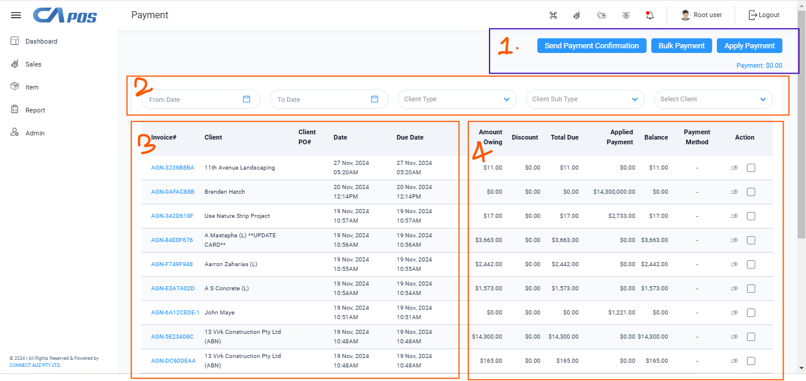

1. **Send Payment Configuration:**

1.1 We can select an invoice number and then click the **"Send Payment Configuration"** button to proceed with processing the invoice.

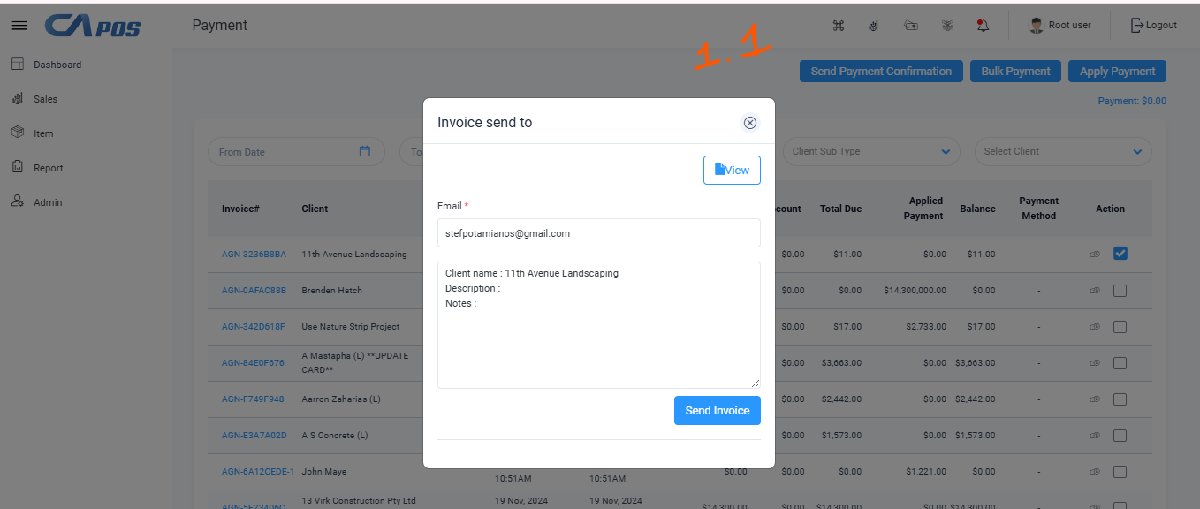

## **Bulk Payment:**

1.2.1 We can manually payment “ Client type” “client subtype” “client Name” “Payment Method “ “Amount “ and “Note “ with section.

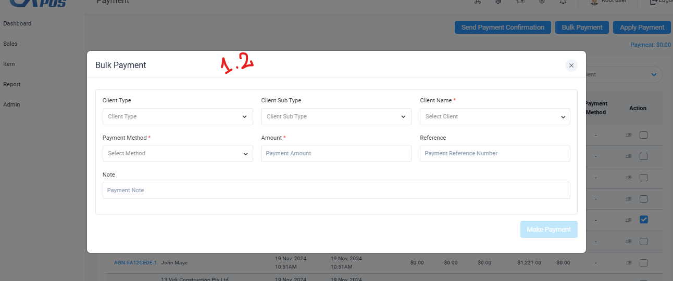

* 1. Add payment:

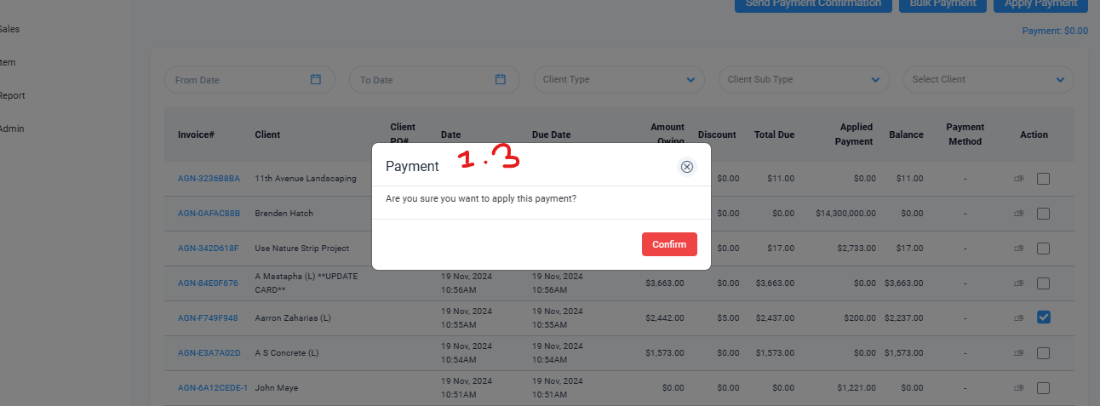

* + 1. We can also manually payment “Add payment “ with section

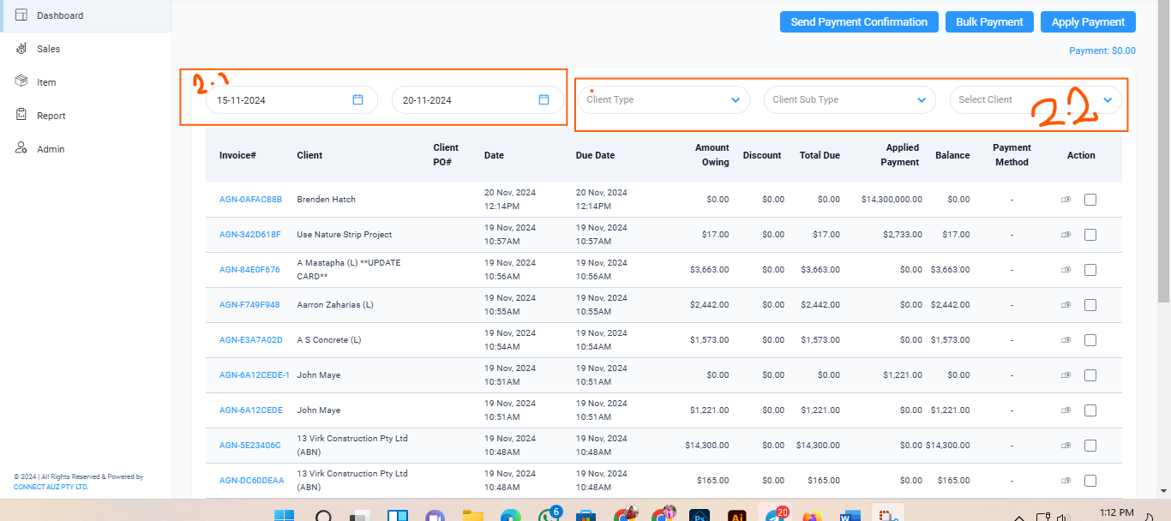

2.1 When we select the “**From Date”** to “**To Date”** section, we can view the following information: **Invoice#**, **Client**, **Client PO#**, **Date**, **Due Date**, **Amount Owing**, **Discount**, **Total Due**, **Applied Payment**, **Balance**, **Payment Method**, and **Action**.

2.2 We can select “client type” “client Sub-Type” and “select client” dropdown and view the payment information.

Top of Form

Bottom of Form